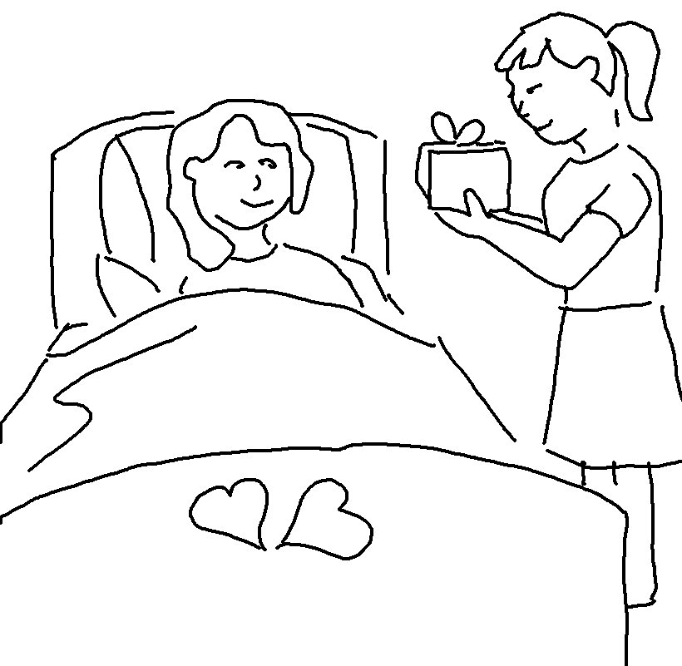
In the same way, let your _ _ _ _ deeds shine out for _ _ _ to see, so that everyone will _ _ _ _ _ _ your heavenly Father.
Matthew 5:16 _{NLT}

